**BLOCK DIAGRAM:**

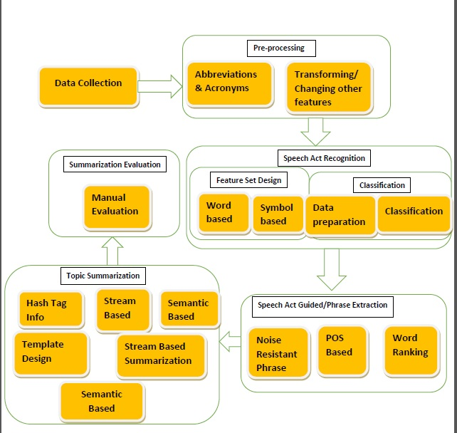

**LIST OF COMPLETED MODULES:**

* Data collection
* Pre-processing
* Speech-act Recognition
* Phrase Extraction**(**one sub-module completed)
* Summarization(two sub-module completed)

**LIST OF PENDING MODULES:**

* Phrase Extraction
* Summarization
* Evaluation